Attenzione: il presente documento è strutturato secondo il template “Normale”.
Ciò consente di formattare automaticamente:
- il corpo del testo
- le sezioni del testo
- l’intestazione e la numerazione di pagina
- le note a piè di pagina
- le didascalie di figure e tabelle
- i titoli (su 4 livelli)
Consente inoltre di compilare automaticamente:
- l’indice sommario
- la lista delle figure e la lista delle tabelle
- la bibliografia (a partire dal riferimento intratesto)
- eventuali indici su due colonne

Acknowledgements

I wish to thank the University of Bergamo for having offered me the opportunity to participate to the doctoral program on Intercultural Humanistic Studies coordinated by prof. Alessandra Violi. I am especially grateful to the professors who supported me in this dissertation, as supervisor - prof. Gianfranco Dalmasso - and as co-supervisor - prof. Enrico Giannetto.

Intestazioni e piè di pagina – note di redazione:
Elementi obbligatori
Intestazione:
Sulla pagina dispari: Titolo del capitolo o della sezione – Introduzione, Bibliografia, etc. (massimo 5-6 parole)
Sulla pagina pari: Nome Cognome (dell’autore)
Centrata, Times New Roman 12, Colore Grigio Scuro
Piè di pagina:
Numero progressivo della pagina, a partire dall’Introduzione
Centrato, Times New Roman 12, Colore Grigio Scuro
Ringraziamenti/Acknowledgements – note di redazione:
Elemento facoltativo
Posizione: a pagina dispari, subito dopo eventuale dedica
Paginazione: fuori paginazione
Paragrafo: giustificato, senza rientro
Titolo: Times New Roman 12, grassetto corsivo
Corpo del testo: Times New Roman 12, senza rientro
Interlinea: 1.5. Una riga tra titolo e corpo del testo
Contenuto: nella lingua del corpo della Tesi. Max 2000 caratteri, spazi compresi.

“L’operar senza regole è il più faticoso
e difficile mestiere di questo mondo”
Alessandro Manzoni

“Nous avons la faculté de comprendre
l’immensité de l’incompréhensible”
Edgar Morin
Epigrafe – note di redazione
Elemento facoltativo
Posizione: a pagina dispari, subito dopo eventuali ringraziamenti
Paginazione: fuori paginazione
Paragrafo: allineamento a destra
Corpo del testo: Times New Roman 12, corsivo, tra virgolette come da esempio
Nome dell’Autore: Times New Roman 12
Interlinea: 1.5. Una riga tra ogni citazione e la successiva
Contenuto: nella lingua originale della frase citata, max 1000 caratteri spazi compresi.

Similmente per citazioni introduttive ai singoli capitoli.
Dedication

I would like to dedicate this dissertation to Valeria Solesin and Giulio Regeni, two Italian PhD students who could not complete their doctoral program. They were killed while they were conducting their research: Valeria in France, Giulio in Egypt.
Valeria was one of the victims of the terrorist attack of November 13, 2015 in Paris. Giulio was executed in Cairo after having been kidnapped on January 25, 2016, and tortured to death. His body was discovered on February 3, 2016, and there are still no details on his murder. The international community asks for justice and truth on Giulio’s execution.
Dedica/Dedication – note di redazione:
Elemento facoltativo
Posizione: a pagina dispari
Paginazione: fuori paginazione
Paragrafo: giustificato, senza rientro
Titolo: Times New Roman 12, grassetto corsivo
Corpo del testo: Times New Roman 12, senza rientro
Interlinea: 1,5; una riga tra titolo e corpo del testo
Contenuto: nella lingua del corpo della Tesi. Max 800 caratteri, spazi compresi.

Table of contents
Introduction 1
Chapter 2. Materials and method 2
2.1 A study which combines qualitative and quantitative research 3
2.1.1 Basic aspects 3
Conclusions 7
Appendices 9
Appendix 1 10
Approvazione dello schema di convenzione tra Comune di Bergamo, Provincia di Bergamo, Regione Lombardia e Infrastrutture Lombarde per la riqualificazione dello svincolo autostradale A4 e della connessione con l’Asse Interurbano di Bergamo 10
References 13
List of figures 15
List of tables 17
Annex 19
Indexes 21
Index of names 22

Indice - Sommario/Table of contents – note di redazione:
Elemento obbligatorio
Posizione: a pagina dispari, subito dopo eventuale dedica/ringraziamenti/epigrafe
Paginazione: fuori paginazione
Struttura e numerazione: come da esempio
Carattere Titolo: Times New Roman 16, grassetto corsivo
Carattere testo dell’indice: Times New Roman 12, grassetto
Interlinea: 1.5. Una riga tra titolo e corpo del testo
Contenuto: nella lingua del corpo della Tesi.

Introduction

This study aims to propose a transcultural and transdisciplinary approach to academic teaching mediated by dialogue. It focuses on a transcultural and transdisciplinary perspective, rather than on the two as separate, thus on the approach to cultures and disciplines together. In particular, it presents the approach to academic teaching on the basis of the relationship among cultures and disciplines, moreover, among, across and beyond cultures and disciplines. They are the three meanings of the Latin prefix trans, of“transcultural” and “transdisciplinary”, according the perspective of transdisciplinarity, proposed by Basarab Nicolescu, contemporary Romanian physicist and philosopher, to which this study refers.
Furthermore, this research is focused on the relationship in terms of “a space of relationship” among, across and beyond cultures and disciplines. This space is provided by dialogue, according the perspective of the philosophy of dialogue, a branch of contemporary Anglo-European philosophy founded by Martin Buber (Blenkinsop, 2006).
This study aims to apply the transdisciplinary perspective to academic teaching mediated by the philosophy of dialogue. This implies the investigation of dialogue as a space of relationship, rather than for relationship among, across and beyond cultures and disciplines. In this perspective, dialogue and relationship may become the same, as they are linked to each other, thus, this proposed approach to teaching aims to investigate also the reciprocity between dialogue and relationship. […..]
Introduzione/Introduction – note di redazione:
Elemento facoltativo
Posizione: a pagina dispari, subito dopo l’indice - sommario
Paginazione: inizio paginazione principale
Paragrafo: giustificato, senza rientro
Titolo: Times New Roman 16, grassetto
Corpo del testo: Times New Roman 12, senza rientro
Interlinea: 1.5. Una riga tra titolo e corpo del testo
Contenuto: nella lingua del corpo della Tesi. Max 10000 battute compresi gli spazi.
Numerazione dei capitoli: fuori dalla numerazione
NB: nella testatina delle pagine dispari porre “Introduzione”

Chapter 1. Materials and method

A chapter for “materials and method” generally follows the introduction and presents the materials and method(s) used in the study, serving as the basis of the results, or findings, and their analysis, which are usually presented in the successive chapter. The method(s) is related to the materials used, as the research, especially in a quantitative approach, is often conducted with instrumentation and procedures which it is necessary to describe.
Therefore, this chapter commonly includes the details which allow readers to understand how the materials and method(s) work, and why we have chosen them. Thus, the information on the equipment and sampling, if present, the measurement, the data (or findings) collection, and the model and the statistics used to analyse them, when possible.
We would say that the relationship between the materials and the method(s) should be mutual: we would not be able to collect the data without the materials necessary to produce them, and, at the same time, it is requested one (or more) method(s) to use these materials and one (or more) method(s) to analyse the data. In fact, we could not demonstrate the validity of the hypothesis without the experimental observations, and the results would be meaningless without their interpretation.
The term “method” is different from “methodology”, and they are not synonymous: the first literally means the “way of doing anything”, from the ancient Greek methodos, a word composed by meta (“after”), and hodos (“way”), while “methodology”, indicates “the study” (logos) of the “method”. Therefore, the methodology investigates which method(s) may be applied to a study, and this implies that the methodology of the research is one, while the methods may be multiple.
The methodology of this study is the one of transdisciplinarity (section 1.3.3), as this research is focused on the proposal of a transcultural and transdisciplinary approach to academic teaching mediated by dialogue. Therefore, in this chapter we do not mention the methodology again, given that it was sufficiently introduced in chapter 1. Instead, I present the characteristics of this proposed approach, especially the basic aspects and the measurement of this study (section 2.1). Furthermore, I describe the materials which I developed during these years, for each course and context of teaching (section 2.2) and related to the content and the tools (section 2.3).
These aspects permit defining the “way of doing” this proposed approach, thus “the method” of this transcultural and transdisciplinary perspective applied to academic teaching and mediated by dialogue.
As previously noted, this approach, at the moment, is little investigated, therefore, the details which will be described are basic to select and order the findings, to analyse them (chapter 3), and to illustrate the implications of this teaching proposal (chapter 4). I now outline the characteristics of this study, which derives from the combination of qualitative and quantitative research, and its measurement.

2.1 A study which combines qualitative and quantitative research
The combination of qualitative and quantitative research seems common in some areas of the “social sciences”, according to William M. Trochim, a U.S. scholar of applied social research methods (Trochim, Donnelly, & Arora, 2015). Nevertheless, it may be new in other areas of investigation, thus I present a few topics, to better understand the characteristics of this study. A common opinion among scholars, even of different areas of research, is that qualitative and quantitative approaches differ for the type of data (findings or results): they are in numerical form in quantitative study, and are in textual form, in qualitative research. [….]

2.1.1 Basic aspects
A research study in the “social” sciences, as well as one which combines qualitative and quantitative approaches, is usually characterized by the following basic aspects: it is “theoretical” when is concerned with “developing, exploring or testing the theories or testing the theories or ideas that the researchers have about how the world operates”; it is “empirical” if is based on “observations and measurements of reality, thus, on what we perceive of the world around us”. These aspects are not opposite, thus a study may be “theoretical” and “empirical” at the same time, when it is based on “a comparison” between the theories and the observations for providing support to them. […]
Capitolo/Chapter – note di redazione:
Elemento obbligatorio
Posizione: a nuova pagina, indifferente pari o dispari, tranne il primo capitolo che è sempre a pagina dispari, subito dopo eventuale introduzione. La numerazione dei capitoli inizia DOPO l’Introduzione
Paginazione: segue paginazione principale
Paragrafo: giustificato, senza rientro
Titolo capitolo: Times New Roman 16, grassetto
Titolo paragrafo: Times New Roman, 14, grassetto
Titolo sottoparagrafo: Times New Roman 12, grassetto
Corpo del testo: Times New Roman 12, senza rientro
Interlinea: 1.5. Una riga tra titolo e corpo del testo, una riga tra paragrafi successivi
Note a piè pagina: numerazione in cifre arabe, riparte ad ogni capitolo; separate dal corpo del testo da linea continua; Times New Roman, 10. Attenzione: la porzione di pagina dedicata alle note non deve idealmente superare ¼ della pagina stessa, e mai comunque la metà.
Esempio di citazione intratesto:

Dei nostri antichi eroi, Signori, udite,
Ne disse, ch’io darò lume e compenso
A le vostre speranze È del gran Giove
Creta quasi gran cuna in mezzo al mare
Isola chiara, e regno ampio e ferace,
Che cento gran città nodrisce e regge.
Citazione di brano intratesto superiore a due righe – note di redazione:
Posizione: con rientro simmetrico a destra e a sinistra, esteticamente adeguato al testo; separata dal corpo del testo da un’interlinea superiore e inferiore
Paragrafo: testo giustificato
Carattere: Times New Roman 11
Interlinea: singola
Nota a piè pagina sulla fonte: distinguere sempre l’unità logica (Virgilio, Eneide III 178) da quella fisica (Paratore-Canali, 1978, p. 16).
Esempi di immagine (compresi i grafici):
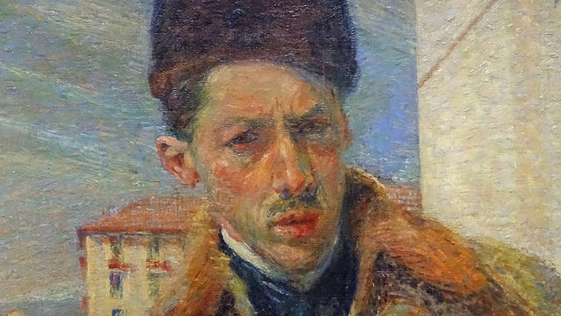
Figura 1: Umberto Boccioni – Autoritratto (1908); Milano, Pinacoteca di Brera. Credits: foto di Maurizio Abbiateci, rilasciata con licenza CC BY, https://www.flickr.com/photos/abbiateci64/32768884545 [visitato il 18/05/2018].

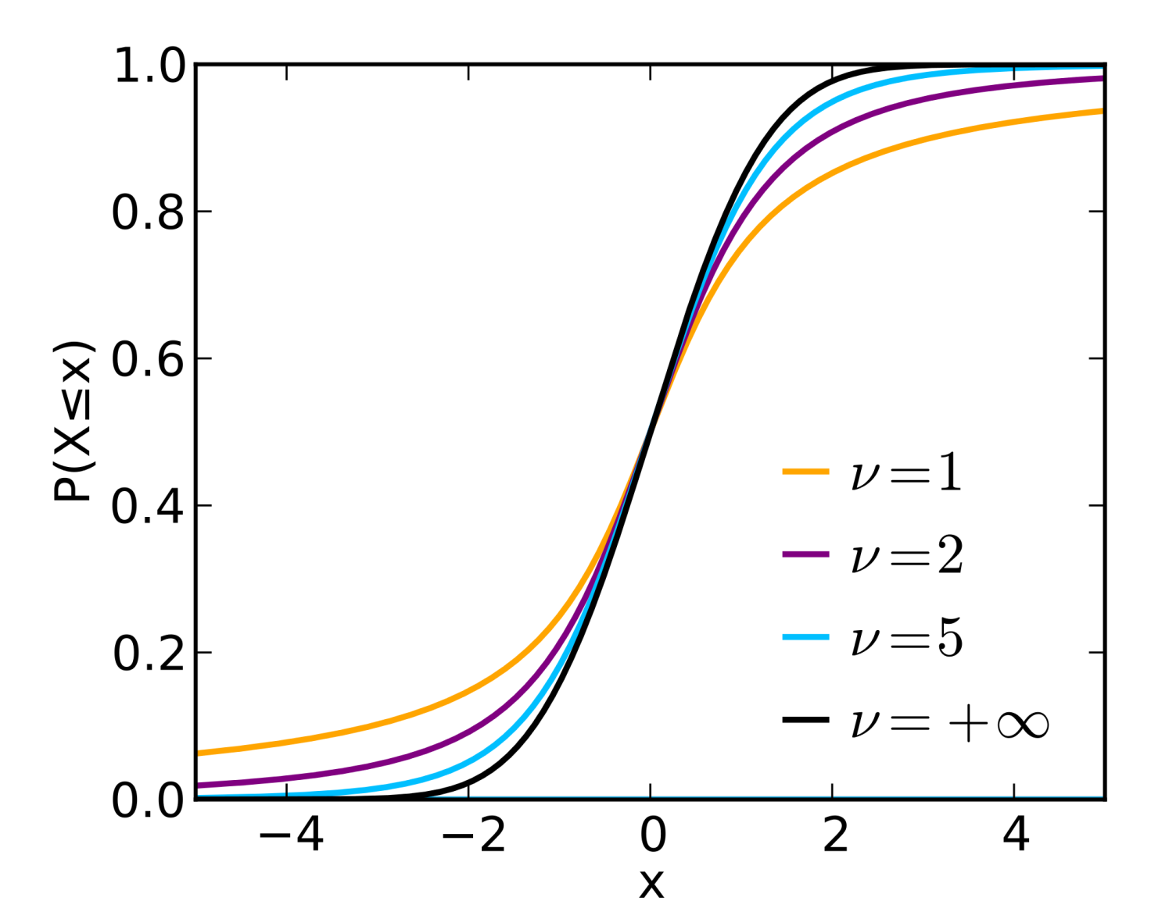
Figura 2: Distribuzione t di Student: funzione di ripartizione
Immagini – note di redazione:
Posizione: centrata; separata dal corpo del testo da un’interlinea superiore e inferiore
Didascalia: obbligatoria. Numerazione progressiva (prefisso: “Figura n:”) per tutto il testo della Tesi
Carattere: Times New Roman 11 grassetto per la didascalia
Interlinea: singola.
Esempio di tabella:

 | Mai (%) | Raramente (%) | Spesso (%) | Molto spesso (%)
Competenze di presa in carico | 0,85 | 10,06 | 46,80 | 38,20
Competenze di educazione |  | 11,90 | 42,10 | 45,90
Competenze diagnostiche | 8,50 | 38,70 | 40,40 | 12,30
Competenze di gestione delle situazioni | 0,40 | 2,90 | 31,90 | 64,60
Interventi terapeutici | 0,85 | 2,90 | 45,90 | 50,20
Assicurare la qualità | 5,10 | 31,40 | 48,00 | 15,30
Ruolo | 2,50 | 14,40 | 50,20 | 32,70

Tabella 1: Frequenze percentuali della frequenza d’uso delle competenze infermieristiche nelle sette classi della NCS

Conclusions
Tabelle – note di redazione:
Posizione: centrata; separata dal corpo del testo da un’interlinea superiore e inferiore
Didascalia: obbligatoria. Numerazione progressiva (prefisso: “Tabella n:”) per tutto il testo della Tesi
Carattere: Times New Roman 11 grassetto per la didascalia
Interlinea: singola.

The purpose of this study was to describe a transcultural and transdisciplinary approach to academic teaching mediated by dialogue. This research aimed to provide evidence that the transdisciplinary and transcultural perspectives may become one, as they are mutually related. In particular, transcultural dialogue needs transdisciplinary dialogue to be realised, and, at the same time, transdisciplinary dialogue needs a transcultural approach to be established. Furthermore, dialogue among, across and beyond cultures may be the basis for dialogue among, across and beyond disciplines. And, vice versa, the transdisciplinary perspective may be the basis for the transcultural one. They cannot be separated, they are “inherently” related to each other, as the Charter on transdisciplinarity indicates (section 1.3.4). Nevertheless, the reciprocity between transcultural and transdisciplinary approaches is not mentioned in this approach to transdisciplinarity, and it seems little investigated. [….]
Conclusioni/Conclusions – note di redazione:
Elemento facoltativo
Posizione: a nuova pagina, indifferente pari o dispari
Paginazione: continua paginazione principale
Paragrafo: giustificato, senza rientro
Titolo: Times New Roman 16, grassetto
Corpo del testo: Times New Roman 12, senza rientro
Interlinea: 1.5. Una riga tra titolo e corpo del testo
Contenuto: nella lingua del corpo della Tesi. Max 6000 battute compresi gli spazi.
NB: nelle testatine delle pagine dispari porre “Conclusioni”

Appendices
Pagina-snodo Appendici/Appendices – note di redazione
Elemento facoltativo
Posizione: a nuova pagina, sempre dispari
Paginazione: continua paginazione principale
Carattere: Times New Roman 16, grassetto, centrato orizzontale.
NB: nelle testatine delle pagine dispari porre “Appendici”

Appendix 1
Approvazione dello schema di convenzione tra Comune di Bergamo, Provincia di Bergamo, Regione Lombardia e Infrastrutture Lombarde per la riqualificazione dello svincolo autostradale A4 e della connessione con l’Asse Interurbano di Bergamo

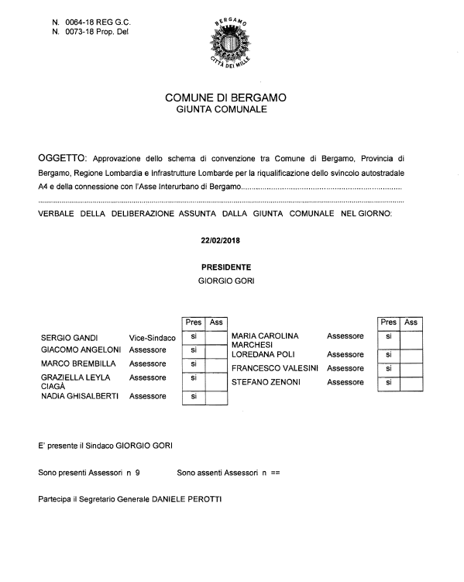

Possibili tipologie di Appendice:
- La versione originale di un testo raro;
- Il testo originale di una legge o di un decreto legislativo;
- Un documento d’importanza storica;
- La traduzione di una poesia o di un racconto;
- Interviste;
- Testi dei questionari somministrati;
- Elenco dei prodotti scientifici già pubblicati dall’autore;
- Dati statistici;
- Altra documentazione.
Appendici/Appendices – note di redazione
Elemento facoltativo
Paginazione: segue paginazione principale
Posizione di ciascuna Appendice: a nuova pagina, indifferente pari o dispari
Inizio ciascuna Appendice: scritta “Appendice n.” con numerazione progressiva in cifre arabe delle singole appendici
Carattere scritta “Appendice n.”: Times New Roman 14, grassetto
Caso 1- Documento dell’Autore
Titolo proprio Appendice: Times New Roman 14, grassetto. una interlinea dopo la scritta “Appendice n.”
Corpo Appendice: Times New Roman 12, una interlinea dopo il titolo
Paragrafo: giustificato, senza rientro
Interlinea: 1.5
Caso 2 – Riproduzione di un documento esterno (cfr. esempio)
Inserire il documento così come reperito, senza apportare modifiche
Titolo proprio Appendice: è costituito dal titolo del documento originale. Times New Roman 12, grassetto, giustificato

Note a piè pagina: numerazione in cifre arabe, riparte ad ogni capitolo; separate dal corpo del testo da linea continua; Times New Roman 10. Attenzione: la porzione di pagina dedicata alle note non deve idealmente superare ¼ della pagina stessa.

List of figures
Figura 1: Umberto Boccioni – Autoritratto (1908); Milano, Pinacoteca di Brera. Credits: foto di Maurizio Abbiateci, rilasciata con licenza CC BY, https://www.flickr.com/photos/abbiateci64/32768884545 [visitato il 18/05/2018]. 5
Figura 2: Distribuzione t di Student: funzione di ripartizione 6

Criteri generali:
Riportare l’esatta didascalia di ogni figura

Indice delle figure/List of figures – note di redazione:
Elemento obbligatorio se applicabile
Posizione: a nuova pagina, dispari
Paginazione: continua paginazione principale
Titolo: Times New Roman, 16, grassetto
Paragrafo: giustificato, senza rientro
Corpo del testo: Times New Roman 12, grassetto
Interlinea: 1.5. Una riga tra titolo e corpo del testo e tra gli elementi dell’elenco.
NB: nelle testatine delle pagine dispari porre “Indice delle figure”. I grafici vengono considerati figure

List of tables
Tabella 1: Frequenze percentuali della frequenza d’uso delle competenze infermieristiche nelle sette classi della NCS 7
Criteri generali:
Riportare l’esatta didascalia di ogni tabella

Indice delle tabelle/List of tables – note di redazione:
Elemento obbligatorio se applicabile
Posizione: a nuova pagina, dispari
Paginazione: continua paginazione principale
Titolo: Times New Roman 14, grassetto
Paragrafo: giustificato, senza rientro
Corpo del testo: Times New Roman 12
Interlinea: 1.5. Una riga tra titolo e corpo del testo e tra gli elementi dell’elenco.
NB: nelle testatine delle pagine dispari porre “Indice delle tabelle”

References
Blenkinsop, S. (2006). Martin Buber: Educating for Relationship. Ethics, Place & Environment, 8(3), 285-307.
Trochim, W., Donnelly, J. P., & Arora, K. (2015). Research Methods: The Essential Knowledge Base. Toronto: Cengage.

Criteri generali:
Utilizzare lo stile citazionale pertinente al Settore Scientifico Disciplinare di afferenza
Non si distinguono le risorse in base al formato (cartaceo o digitale), ma si distinguono le risorse non in forma di rivista/volume: la sitografia va posta dopo la bibliografia.
Da un punto di vista contenutistico, si distinguono le opere in base al Settore Scientifico disciplinare di afferenza. Ad esempio, in ambito umanistico, tra fonti originali e secondarie. Anche in ambito scientifico se possibile distinguere le fonti dalla letteratura utile.
Bibliografia/References – note di redazione:
Elemento obbligatorio
Posizione: a nuova pagina, dispari
Paginazione: continua paginazione principale
Titolo: Times New Roman, 16, grassetto
Paragrafo: giustificato, senza rientro
Corpo del testo: Times New Roman 12
Interlinea: 1.5. Una riga tra titolo e corpo del testo.
NB: nelle testatine delle pagine dispari porre “Bibliografia”

Annex
Archivio video (supporto DVD; min 1.500)
Allegati/Annex – note di redazione:
Elemento facoltativo
Posizione: a nuova pagina, dispari
Paginazione: continua paginazione principale
Titolo: Times New Roman 16, grassetto
Paragrafo: giustificato, senza rientro
Corpo del testo: Times New Roman 12
Interlinea: 1.5. Una riga tra titolo e corpo del testo e tra gli elementi dell’elenco.
NB: nelle testatine delle pagine dispari porre “Allegati”

Indexes
Pagina-snodo Indici/Indexes – note di redazione
Elemento facoltativo
Posizione: a nuova pagina, sempre dispari
Paginazione: continua paginazione principale
Carattere: Times New Roman 16, grassetto, centrato orizzontale.
NB: nelle testatine delle pagine dispari porre “Indice (analitico o altro)”

Index of names
Abelardo, Pietro, 184
Achella, Stefania, 65, 72, 79, 86
Agostino d’Ippona, 30, 34, 51
Alberto Magno, 21, 22, 28-31, 39, 46-
48, 54, 56
Alessandro di Afrodisia, 26, 39
Alessandro Magno, 55
Alighieri, Dante, 68
Alverny, Marie-Therese d’, 51
Amoroso, Leonardo, 66, 82
Anceschi, Luciano, 169
Anders, Gunther, 221, 225
Andersen, Hans Christian, 104
Antistene, 181
Anzulewicz, Henryk, 21
Ardovino, Adriano, 65
Arendt, Hannah, 112-114, 117, 121
Aristofane, 68
Aristotele, 21-23, 25, 26, 28-37, 41-46,
49, 50, 55, 58, 170-172, 176, 177
Averroe, 21, 22, 26, 28, 29, 33, 37, 39,
42, 43, 49, 50, 52-55
Avicenna, 25, 29, 30, 36, 37, 41, 51,
54, 56
Baker R., Lynne, 103
Baldassarre, profeta, 40
Baptist, Gabriella, 101
Barwise, Jon, 165
Bateson, Gregory, 197
Battistini, Andrea, 114
Beck, Ulrich, 213, 218
Beiser, Frederick, 65
Berg-Hildebrand, Andreas, 126-127
Bergson, Henri, 104
Bloch, Ernst, 112, 122
Bloch, Ernst, 6, 12, 15, 20
Boccaccio, Giovanni, 99
Bodei, Remo, 63
Bodei, Remo, 99, 111, 115
Bohm, Wilhelm, 81
Bondeli, Martin, 72, 73, 74, 76, 80
Bonsiepen, Wolfgang, 89
Borgnet, Auguste, 22
Bouveresse, Jacques, 132
Boym, Svetlana, 98, 113
Brague, Remi, 105, 106, 114, 121
Braque, Georges, 99
Braun, Hermann, 81, 83
Brecht, Bertolt, 122, 123
Bruto, Marco Giunio, 41, 44
Bubner, Rudiger, 81
Bucci, Paolo, 121
Bulow, Ulrich, 65
Calogero, Guido, 179
Campanini, Massimo, 28
Campbell, Craig, 217
Carchia, Gianni, 98
Carlier, Jeannie, 96
Carnap, Rudolf, 187, 190
Cartesio, vedi Descartes
Casati, Roberto, 103, 117
Cassirer, Ernst, 179
Cattaneo, Francesco, 167, 177
Celestino V, papa, 44
Cerutti, Furio, 212
Cesa, Claudio, 81, 82
Cesare, Caio Giulio, 36
Ceserani, Remo, 98, 101
Cezanne, Paul, 99
Chesterton, Gilbert K., 124
Chomsky, Noam, 189
Ciancio, Claudio, 103
Cicerone, Marco Tullio, 39, 41, 105,
106
Coffa, Alberto, 188
Cortassa, Guido, 96
Altri indici (es. Indice dei nomi, dei luoghi …) – note di redazione:
Elemento facoltativo
Paginazione: continua paginazione principale
Posizione di ciascun indice: a nuova pagina, indifferente pari o dispari
Titolo di ciascun indice: Times New Roman 14, grassetto
Paragrafo: giustificato, senza rientro, se appropriato anche su due colonne come da esempio
Corpo del testo: Times New Roman 12
Interlinea: Singola. Una riga tra titolo e corpo del testo e tra gli elementi dell’elenco.
NB: nelle testatine delle pagine dispari porre “Indice (analitico o altro)”

It is an online source, and there are no page numbers, but the contents are divided into paragraphs and sections, which I reported.
Virgilio, Eneide III 178-183 in Paratore – Canali 1978, p. 16.
Reperibile all’indirizzo web https://www.comune.bergamo.it/servizi/delibere/ricerca_fase03.aspx?ID=103605 [visitato il 18/05/2018].

